***EXPERIMENT***

***AIM :*** Design an automatic night lighting system (with 4 connected led’s) such the system is only activated when the master control switch is pressed. a) Below 50% value of full brightness all LED’s constantly ON. b) Above 50% value of full brightness only first LED is ON

***Apparatus:*** Arduino,LDR,LED,Resistor(10k,220),wires,beardboard

***Circuit Diagram***

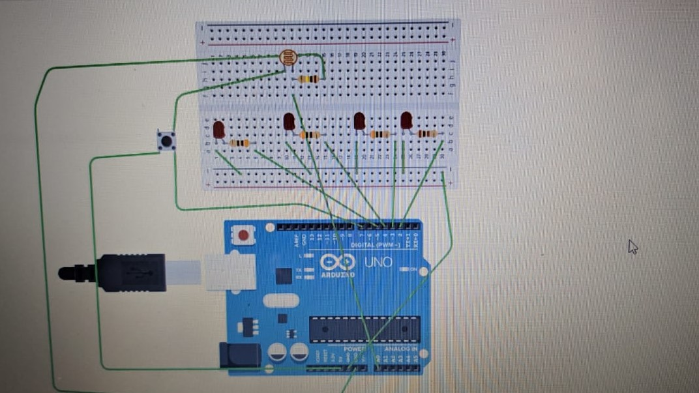

Program

***​***int c = 2;

void setup() {

Serial.begin(9600);

pinMode(7,INPUT);

pinMode(2,OUTPUT);

pinMode(3,OUTPUT);

pinMode(4,OUTPUT);

pinMode(5,OUTPUT);

}

void loop() {

int a =analogRead(A0);

int b =digitalRead(7);

Serial.println(a);

if (b ==HIGH)

{

c++;

}

if ( (c % 2) == 0)

{

digitalWrite(2,LOW);

digitalWrite(3,LOW);

digitalWrite(4,LOW);

digitalWrite(5,LOW);

}

else

{

if(a<1015)

{

digitalWrite(2,HIGH);

digitalWrite(3,HIGH);

digitalWrite(4,HIGH);

digitalWrite(5,HIGH);

}

else

{

digitalWrite(2,HIGH);

digitalWrite(3,LOW);

digitalWrite(4,LOW);

digitalWrite(5,LOW);

}

}

}

**RESULT**

Automatic night lamp functioning was verified after uploading the program